5/28/2014

Neilson Leslie

Bryan Pope

Brandon Coulthard

Andrew Best

TOTAL APOCALYPSE: Road Rage

Game Design Document

Version 0.1

Contents

1. Game Overview 2

1.1 Objective 2

1.2 Genre 2

1.3 Audience 2

1.4 Platform/Minimum System Requirements 2

2 Plot & Setting Information 2

2.1 The Story 2

3 Core Gameplay 2

3.1 Movement 2

3.1.1 Map Level 2

3.1.2 In Battle 2

3.2 Road Combat 2

3.2.1 Modes of Combat Resolution 2

3.2.2 Abstract Road Combat 2

3.2.3 Crew Deployment 2

3.2.4 Quick Combat 2

3.2.5 Tactical Combat 2

4 Environment Elements 3

4.1 Environment 3

4.1.1 List of Cities 3

4.1.2 Terrains 3

4.2 Vehicles 3

4.2.1 Vehicle Attributes 3

4.2.2 Maintenance 3

4.2.3 Improvements 3

4.3 Supplies 3

4.3.1 Carrying Capacity 3

4.3.2 Consumption 3

4.3.3 Caches 3

4.3.4 Special Supplies 3

4.4 People 3

4.4.1 Gangs 3

4.4.2 Encounters 3

5 Interface Usage 3

5.1 Controls 3

6 Menu and General Game Usage 3

6.1 Screen Descriptions 3

6.2 Game Flow Diagram 3

# Game Overview

## Objective

## Genre

## Audience

## Platform/Minimum System Requirements

# Plot & Setting Information

## The Story

# Core Gameplay

## Movement

### Map Level

Every action performed in the overhead map, takes some time but more importantly at least one of your resources is consumed. For example, your food resource is constantly depleted at a fixed number proportionate to the number of people you have in your group.

Other global conditions that can occur as the player progresses are weather conditions (snow, rain, tornadoes, etc.). When the player does an action, there is a random chance that there is an impact from the current weather condition. There are also the random generated cases of sickness/disease and attacks from other gangs.

On the overhead map, the player moves by first selecting his vehicular avatar and then select the destination. The vehicle will move from its current location to the destination. Once it reach the destination for the first time, it auto search for loot, people, vehicles. Being on a tile textured with particular material can increased the chances of finding particular resources.

The player can select the avatar and an option list scrolls up from the bottom of the screen. The option list is:

* Move – Once you choose this option, you can then finger point and select your next destination.
* Search – Once you have moved to a location, you may not want to move right away on next turn. So you can search for more loot, vehicle or people.

So a swipe from the side can bring your current inventory into view and swiping in the opposite direction would remove it so the map becomes in focus and full again.

### In Battle

## Road Combat

### Modes of Combat Resolution

### Abstract Road Combat

### Crew Deployment

### Quick Combat

### Tactical Combat

# Environment Elements

## Environment

### List of Cities

### Terrains

## Vehicles

### Vehicle Attributes

### Maintenance

### Improvements

## Supplies

### Carrying Capacity

### Consumption

### Caches

### Special Supplies

## People

### Gangs

### Encounters

# Interface Usage

## Controls

On the overview map, the player has limited control to press on the surface on the device to select an object, option or location. Swiping the right edge of the screen allows for the player to view or close their inventory screen

# Menu and General Game Usage

## Screen Descriptions

1. Splash screen will be on startup animation showing credits and game concept/gameplay.
2. Title Screen shows the title of the game and acknowledgement of the developer and publisher team.

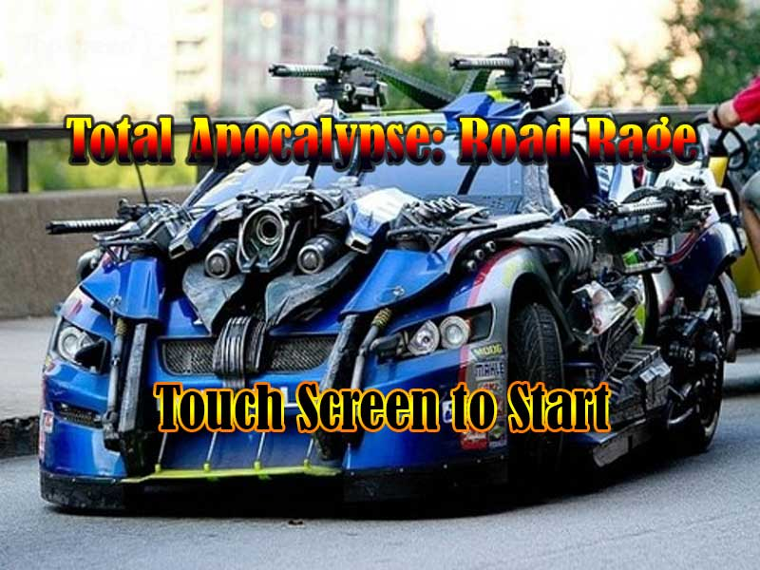

1. The Main Menu screen gives the user the option to make an input to navigate to other screens; Start Game, Options or Credits.

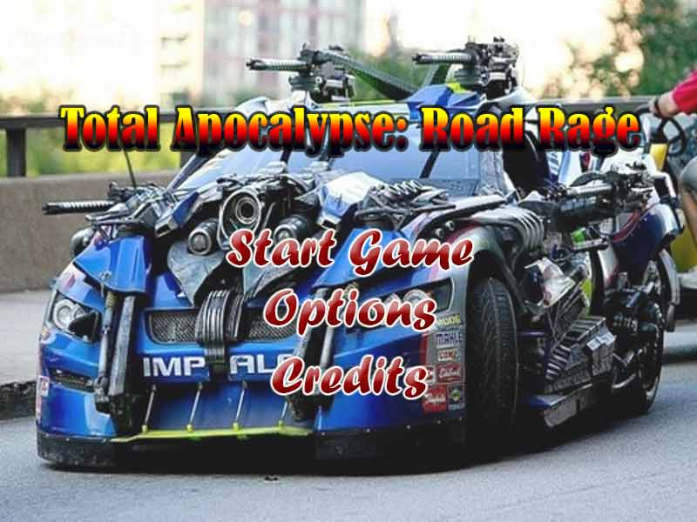

1. The Start Game opens to another screen where the player chooses to start a new game, load a previously saved game or continue from the last autosaved game.

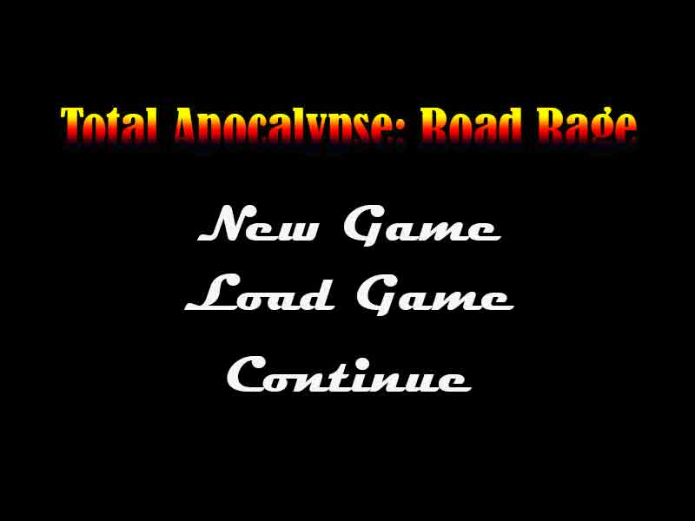

1. New Game takes the player into a new Game.
2. Load Game loads a save file with the Player’s stats, etc into an instance of the game.
3. Continue continues the game of the last player from an autosaved checkpoint.
4. The Option Screen will open to another screen where the player can adjust the sound and music levels.

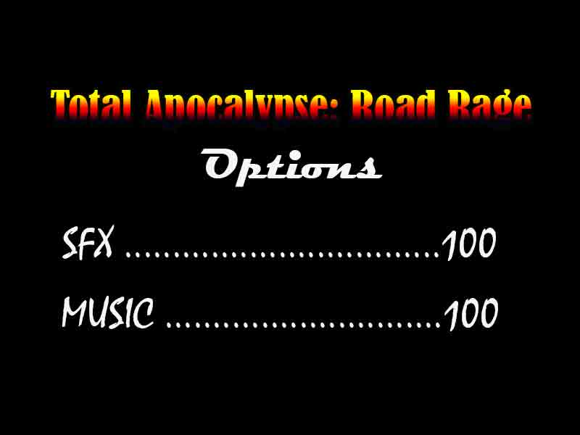

1. The Credits screen lists and acknowledge those who contributed or whose work may be used to make this game.
2. The Game screen is where the in game features and core gameplay happens.
3. When the game is paused, a Pause menu appears which gives the user two choices; Resume or Quit. Resume will continue the game and Quit will take the player back to the Main Menu screen.
4. The Loss or End Game state, gives a screen that asks the Player to retry or Quit. Retry would start the game over. Quit would take the Player back to the Main Menu screen.

## Game Flow Diagram

